1. Starting Point Dancing
2. Question 1

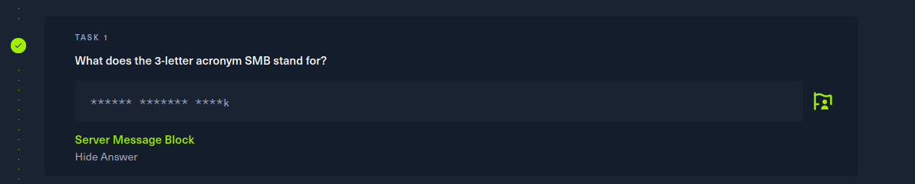

1. Question 2

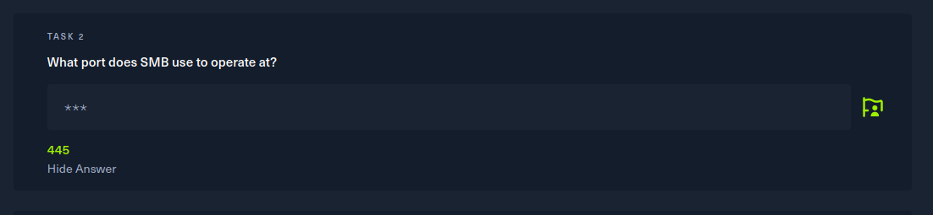

Jalankan “Nmap -sV”

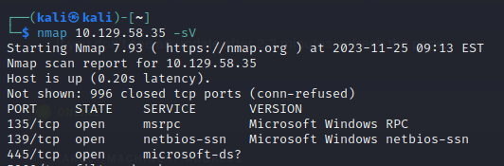

1. Question 3

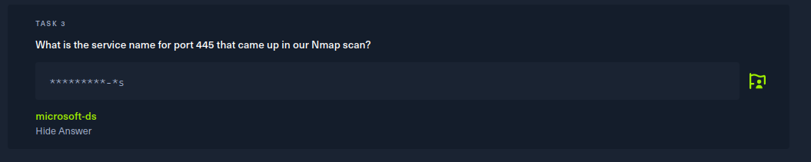

Jalankan “Nmap -sV”



1. Question 4

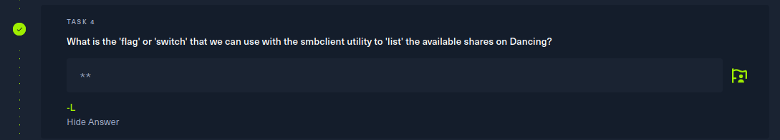

Jalankan “smbclient -h”

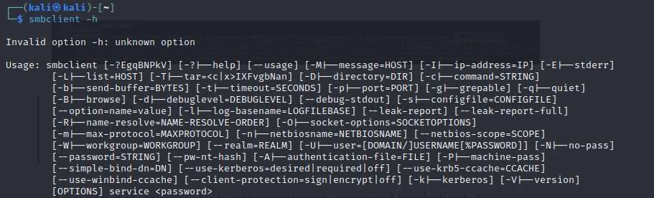

1. Question 5

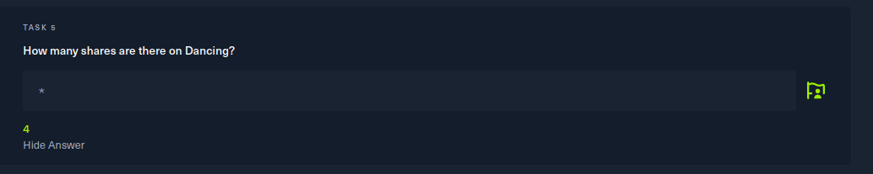

Jalankan “smbclient -L ‘target ip’”

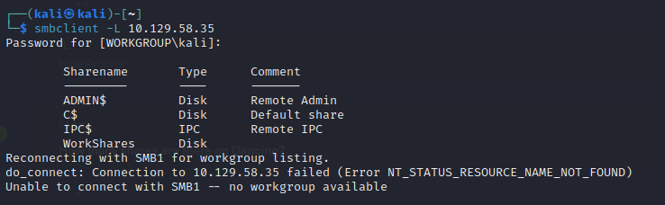

1. Question 6

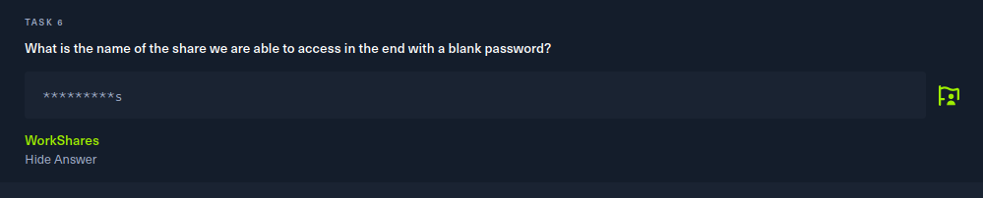

Karena hanya WorkShares yang saat di connect tidak perlu memasukkan password



1. Question 7

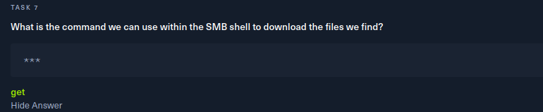

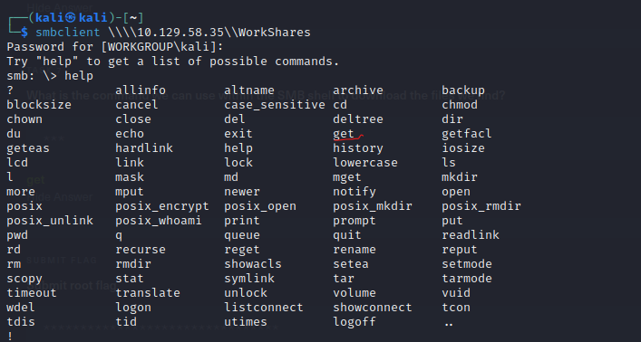

1. Question 8

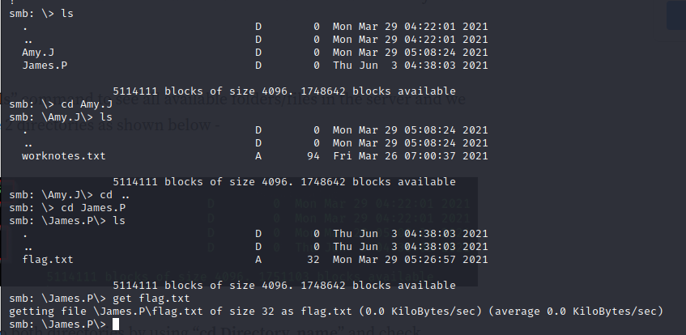

Lalu masuk ke terminal dan mencoba membuka menggunakan nano



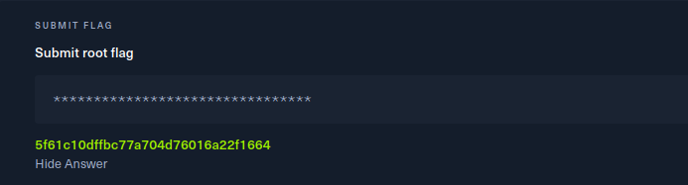

Starting point redeemer

1. Question 1

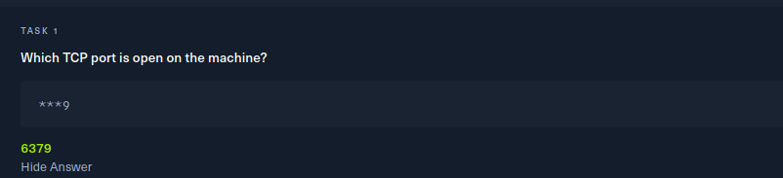

“jalankan nmap -p- ‘ipaddress-nya’ –min-rate 5000”

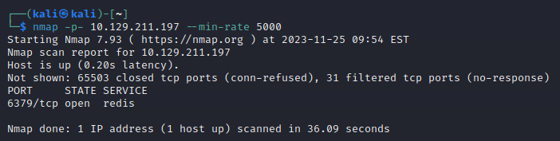

1. Question 2

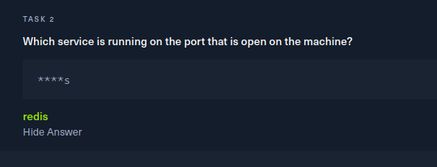



1. Question 3

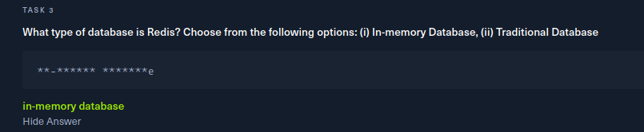

1. Question 4

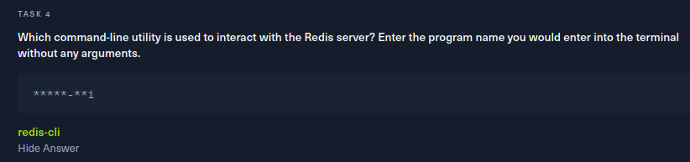

1. Question 5

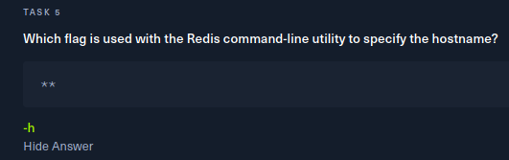

Dengan mengetikkan

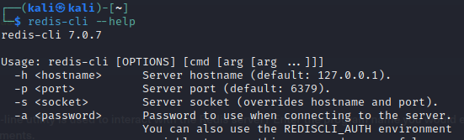

1. Question 6

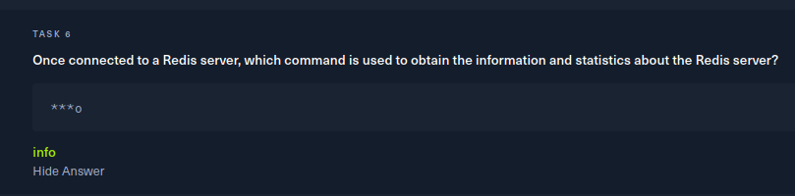

1. Question 7

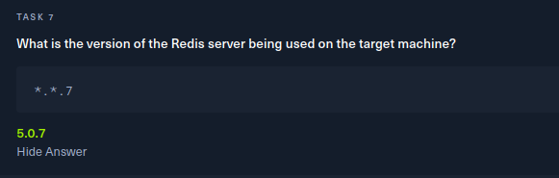

Dengan mengetikkan redis-cli -h “ipaddress” 🡪 info

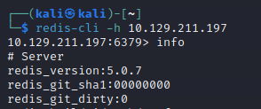

1. Question 8

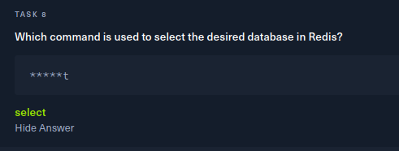

1. Question 9

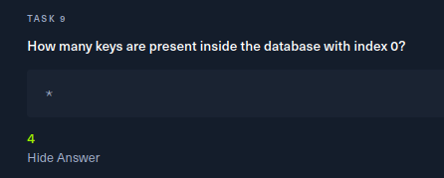

Dengan mengetikkan

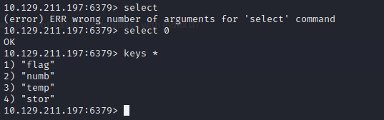

1. Question 10

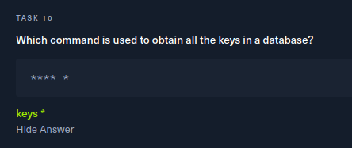

1. Question 11

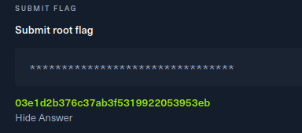

Dengan mengetik



1. a. Report 1

**[CVE-2023-38546] cookie injection with none file**

Jenis kerentanan: cookie injection

Tingkat seveity: Low

CVSS score: 0.5

Remidiasi: Enkripsi yang valid

b. Report 2

**IDOR vulnerability on profile picture changing mechanism which discloses other user's profile picture.**

Jenis kerentanan: IDOR Vulnerability

Tingkat seveity: Medium

CVSS score: 1

Remidiasi: Penggunaan session token

c. Report 3

**HTML injection in search UI when selecting a circle with HTML in the display name**

Jenis kerentanan: XSS-Stored

Tingkat seveity: Low

CVSS score: 0.5

Remidiasi: Content Security Policy (CSP). Terapkan kebijakan keamanan konten (Content Security Policy) untuk membatasi jenis sumber daya yang dapat dimuat dan memitigasi risiko XSS.